EXP NO: 3 IDENTIFY USE CASE AND DEVELOP THE USE CASE MODEL
ProjectTitle: E-Learning Management System (ELMS)
Use Case Description
The Admin manages the overall system by performing activities such as login, managing users, and managing courses. The Instructor creates courses, uploads learning content, creates assessments, and evaluates student performance. The Student logs into the system, enrolls in courses, views learning materials, attends assessments, and tracks their learning progress.

USE CASES:
1. Admin
Login
Admin enters username and password to access the system.
Manage Users
Admin can add, update, or delete users such as instructors and students.
Manage Courses
Admin manages course information and maintains the course database.

2. Instructor
Login
Instructor logs into the system using valid credentials.
Upload Content
Instructor uploads study materials such as notes, videos, or documents.
Create Assessment
Instructor creates quizzes, assignments, or tests for students.
Evaluate Assessment
Instructor checks and evaluates student submissions.

3. Student
Login
Student logs into the system to access learning resources.
Enroll in Course
Student selects and enrolls in available courses.
View Content
Student accesses learning materials uploaded by the instructor.
Attend Assessment
Student takes quizzes or assignments.
View Progress
Student checks marks, results, and learning progress.
USE CASE DIAGRAM:
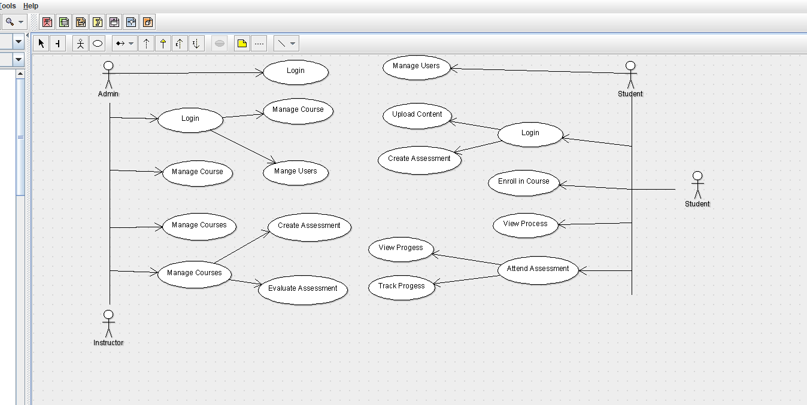

RESULT
Thus, the actors (Admin, Instructor, Student) were successfully identified, and a Use Case Diagram was created to represent the interactions within the E-Learning Management System EXP NO : 4 IDENTIFY THE CONCEPTUAL CLASSES & DEVELOP A DOMAIN MODEL AND ALSO DEVICE CLASS DIAGRAM FROM THAT
ProjectTitle: E-Learning Management System (ELMS)
Domain Model Description
The Domain Model represents the real-world entities and their relationships in the ELMS system manages the overall system operations such as login, logout, and report generation.
User is a general class representing all users of the system.
Admin manages users and courses in the system.
Instructor creates courses, uploads content, and prepares assessments.
Student enrolls in courses and views progress.
Course contains course information such as title and description.
Assessment is used to conduct quizzes and evaluate assignments.
Resource stores learning materials such as videos and documents.
These classes interact with each other to provide a complete e-learning environment.
CLASS DIAGRAM:
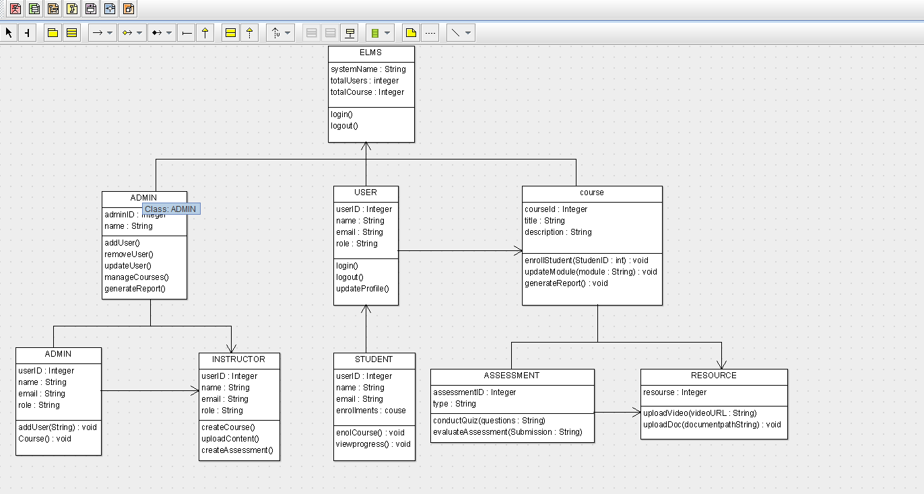
RESULT:
Thus, real-world entities such as User, Admin, Instructor, Student, Course, Assessment, and Resource were successfully identified, the Domain Model was developed, and Class Diagram was created, showcasing relationships, attributes, and methods in the E-Learning Management System (ELMS).
EXP NO:5 USING THE IDENTIFIED SCENARIOS FIND INTERACTIONS BETWEEN OBJECTS AND REPRESENT FROM USING UML SEQUENCE AND COLLABRATION DIAGRAM
ProjectTitle: E-Learning Management System (ELMS)
Sequence Diagram – Description
The Sequence Diagram shows the order of interactions between objects over time.
Example interaction (Student enrolling in a course):
Student sends login request to ELMS.
ELMS verifies user credentials.
Student selects a course.
ELMS sends request to Course class to enroll the student.
Course confirms the enrollment.
Student can then view resources and attend assessments.

SEQUENCE DIAGRAM:
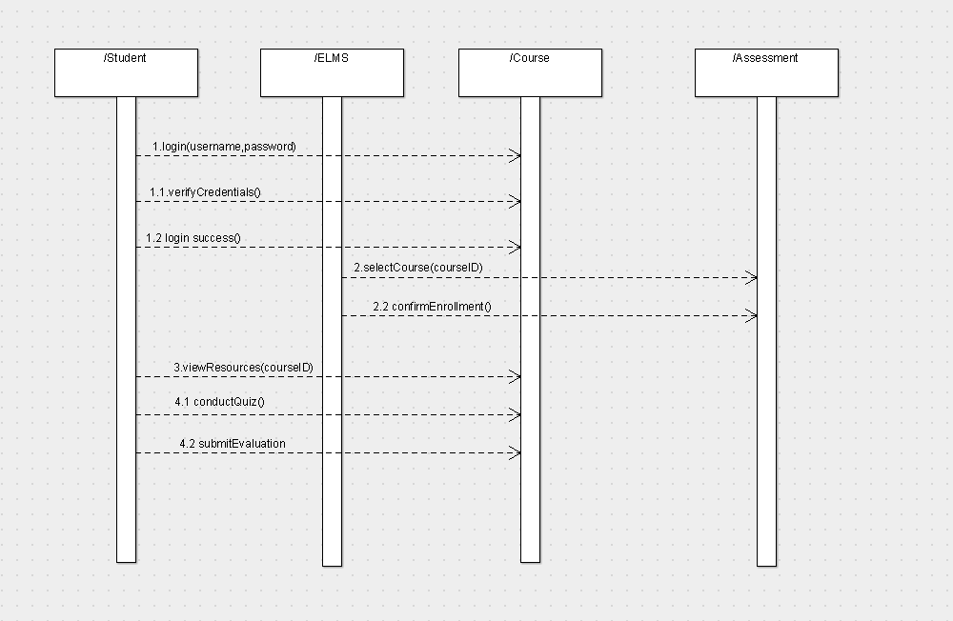

Collaboration Diagram – Description
The Collaboration Diagram (Communication Diagram) shows how objects interact with each other and their relationships.
Admin manages users and courses.
Instructor creates courses and uploads resources.
Student enrolls in courses and participates in assessments.
Course connects students with learning materials.
Assessment evaluates student performance.
Resource provides study materials such as videos and documents.

COLLABRATION DIAGRAM:
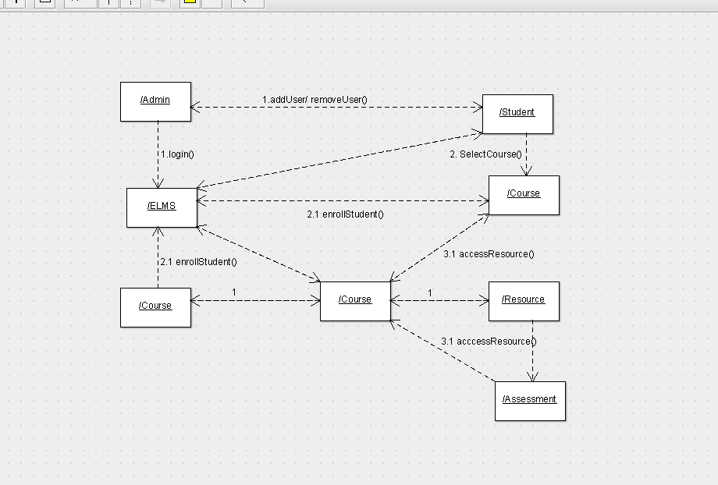

RESULT:
Thus, the identified scenarios were successfully used to create Sequence Diagrams for key interactions (student login, course enrollment, and assessment) and Collaboration Diagrams for object interactions in the ELMS.

EXP NO:6 DRAW RELEVENT STATE CHART AND ACTIVITY DIAGRAMS FOR SAME SYSTEM

ProjectTitle: E-Learning Management System (ELMS)
State Diagram – Description
The State Diagram represents the different states of a student in the E-Learning Management System (ELMS) during system usage.
Initially, the system is in the Logged Out state.
When the user enters valid credentials, it moves to the Logged In state.
After login, the user enters the Course Selection state to choose a course.
Then the system transitions to Resource Viewing where learning materials are accessed.
The user may proceed to Assessment State to attend quizzes or assignments.
Finally, the system reaches the End/Logout state after completing activities.
STATE DIAGRAM:
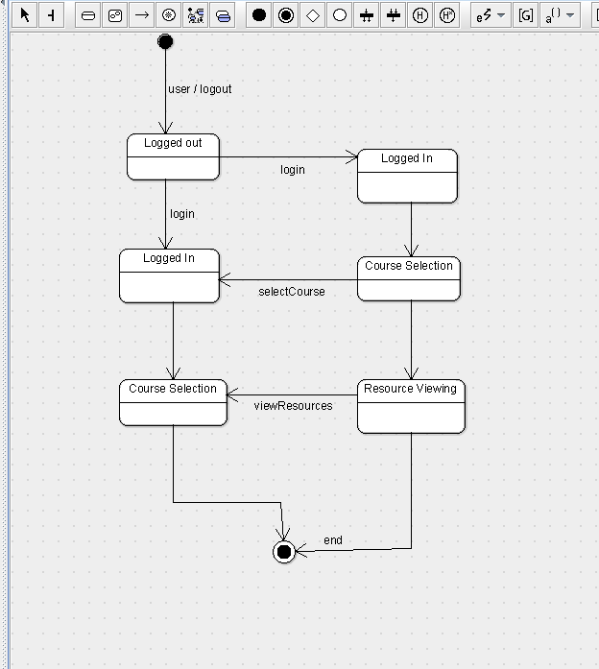

Activity Diagram – Description
The Activity Diagram illustrates the workflow of activities in the ELMS.
The process starts with the Login activity.
The system verifies user credentials using a decision node (valid/invalid).
If valid, the user proceeds to Select Course.
Then the user can View Resources and access study materials.
Next, the user performs Attend Assessment (Quiz).
The system then performs Evaluation of the assessment.
Finally, the process ends after completion of all activities.

ACTIVITY DIAGRAM:
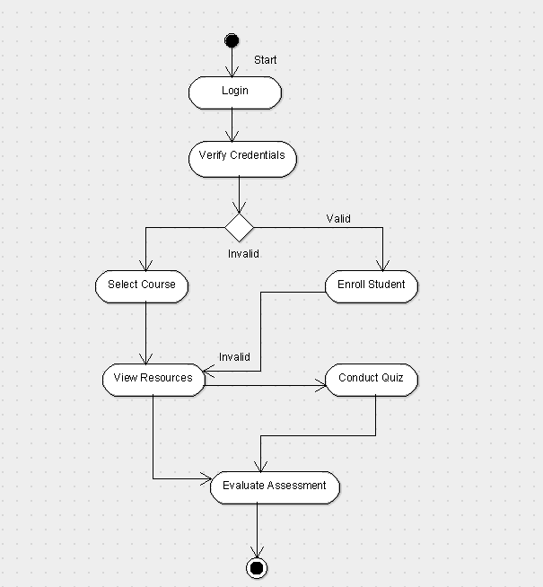

Deployment Description
The Deployment Diagram shows the physical structure of the ELMS system.
It includes Client Device, Web Server, Application Server, and Database Server.
The Client Device (Admin, Instructor, Student) accesses the system through a browser.
The Web Server handles user requests and provides the interface.
The Application Server processes the business logic of the ELMS.
The Database Server stores and retrieves system data such as users and courses.
All components are connected through a network to ensure smooth communication.

DEPLOYMENT DIAGRAM
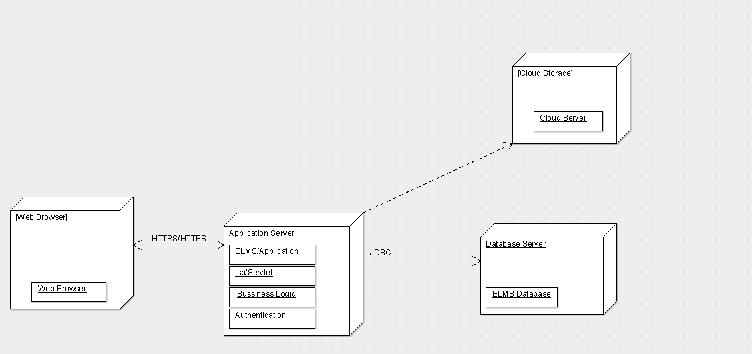

RESULT:
Thus, the state changes of a user and key workflows in the E-Learning Management System (ELMS) were successfully modeled using State Chart and Activity Diagrams.

